

**The Storehouse**

Ain Shams University

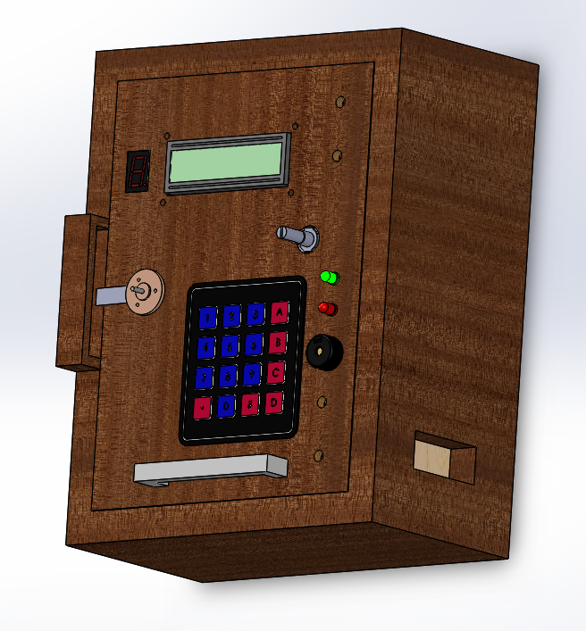

Team Names:

Yasser Mohamed Ibrahim

Yara Hossam Sayed

Section 19

Group 2

**Abstract:-**

إن الله يحبُ إذا عِملً احدٌكم عملًا أن يتقنه" "

Our team is considered to make the hardware project, because we love to do the Robot and we like to learn more at this field.

This project is a storehouse which

**I. Introduction**

A. Abstract

**II. Design Rationale**

A. Mechanical Design Process

B. Design Evolution

C. Electrical Systems

D. Programming

**III. Conclusion**

A. Challenges

B. Lessons Learned and Skills Gained

C. References

**II. Design Rationale**

A. Mechanical Design Process

To streamline the design process, Our team used a multi-step approach to allow the team to envision the end result early in the design process, first We imagine the design on our mind, second we sketched it at paper, finally we design our mechanical design at (CADD) files using Solid Works.

 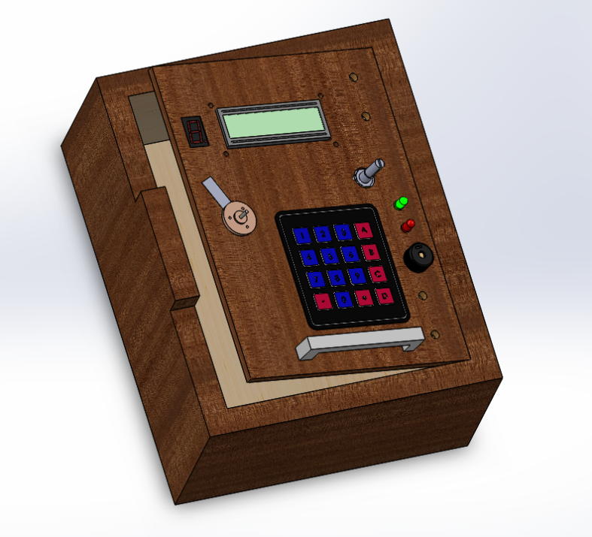

B. Design Evolution

Next, we design our product by the wood and manufactured at our workshop by mechanical machine such as "disk" to cut the wood, "drill" to make a hull at wood to insert our electronics component & "arct" to make the big hull and design it with the displacement.

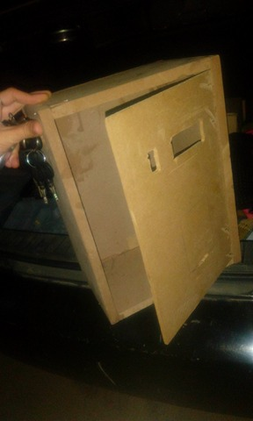

C. Electrical Systems

Our electrical system is passed many of steps to design and evaluate it.

First we decided to used an AVR as a microcontroller and we write all the port we use on excel program to don't use the port more than one time.

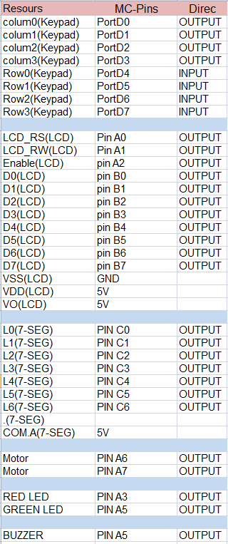

Second, we design our circuit at **Protues** program to simulate it and run the code on it.  
We used many electronics component such as:-

-Atmega32

-LCD

-KeyPad

-Seven_segment

-DC Motor

-2N2222 Transistor

-LEDs

-Buzzer

- Potentiometer

-PCBs

-USBasp Programmer

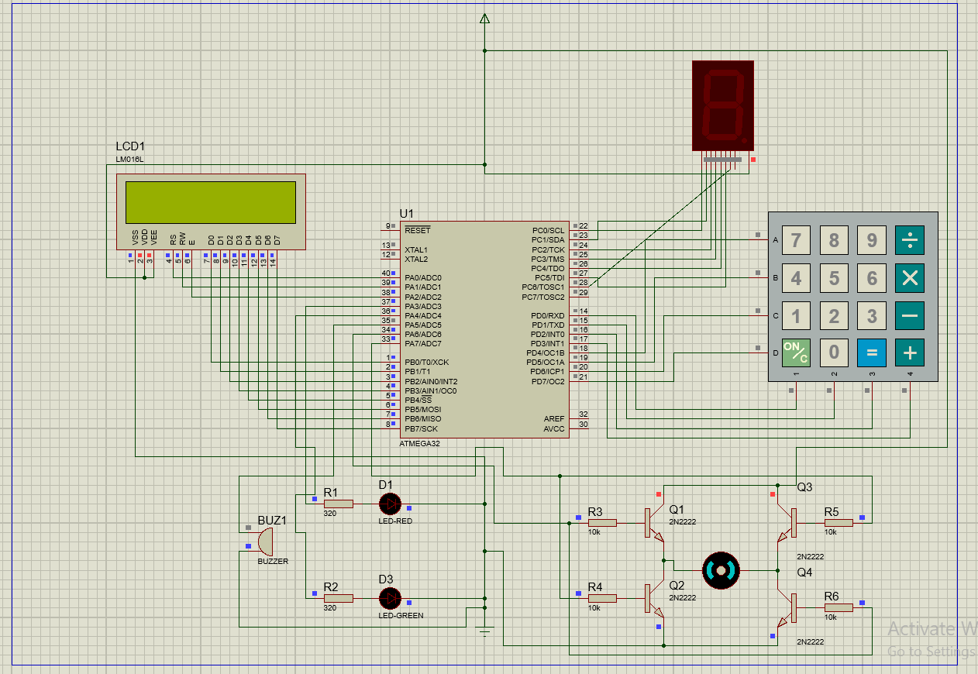

Then we design our circuit on **EAGLE** program to make the circuit a PCB circuit.

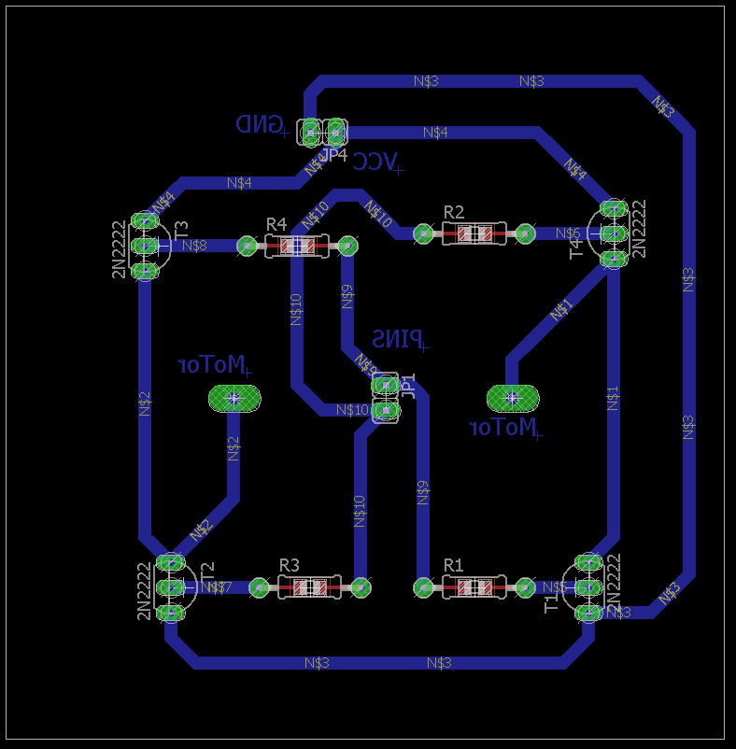

PCB Motor Driver with transistor 2n2222

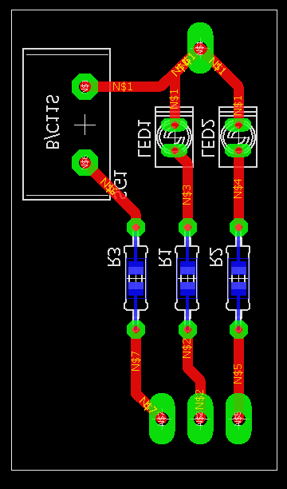

PCB for 2 LEDs & Buzzer

Finally we print the PCB and It's working ☺

D. Programming

We used the **Assembly AVR** to write our code, we write the code on **ATMEL STUDIO 7.0**.

We used many instructions to write our program.

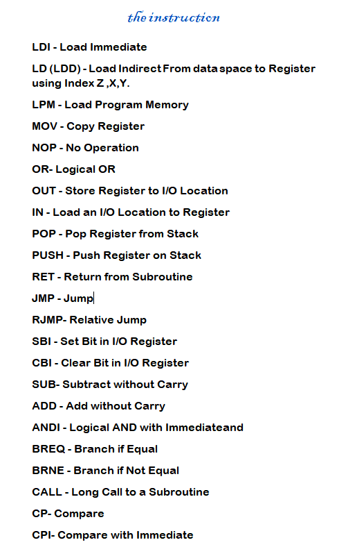

Assembly AVR Instructions

Finally the project ended ☺

**III. Conclusion**

A. Challenge

Our team encountered many challenges from the very beginning until now, the first problem the place to manufacturing our product, we don't find any help at our **Assembly AVR** program in our collage and We do the self-study to making this project this take the large time.

B. Lessons Learned and Skills Gained

**"إِنَّا لا نُضِيعُ أَجْرَ** مَنْ **أَحْسَنَ عَمَلا"**

“We shall not suffer to perish the reward of any who do a (single) righteous deed.”

D. References

AVR Microcontroller and Embedded Systems

<https://drive.google.com/file/d/1isQtOipXtDsvJgt9zDKpOq-4FLc_mBrn/view>

ATMEL*

<http://www.atmel.com/webdoc/avrassembler/avrassembler.wb_instruction_list.html>